Amazon Prime

Prepared by: B. Devi

Date: 14/05/2025

**Introduction**

The Amazon Prime Dashboard Project aims to create a comprehensive and interactive dashboard that visualizes key metrics related to Amazon Prime’s user engagement, content performance, and operational efficiency. The dashboard enables stakeholders to gain actionable insights, monitor performance trends, and make informed business decisions.

**Dataset Overview**

The dataset includes various fields such as content type (movie/series), watch time, Title, Release year, Country, device used, Description and user ratings. The data is sourced from anonymized user interaction logs and internal content tracking systems.

**Data Preparation**

Explain steps taken to clean and transform data in Power BI:

* Removed null or blank rows
* Replaced missing values
* Split columns (e.g., duration into length + type)
* Created calculated columns (e.g., release decade, content category)

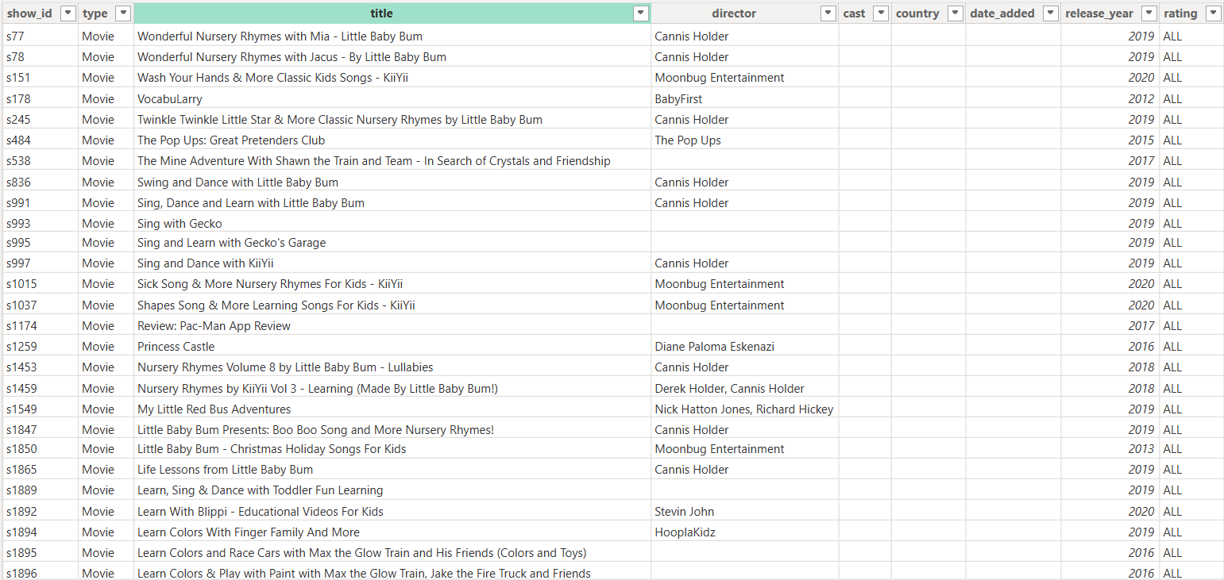

**Data Model**

Include a diagram or description of the data relationships.

*Tables used:*

* Content: Includes title, type, genre, rating
* Country: Mapped from content table
* Date: Custom date table for release analysis

**Key Visualizations and Insights**

The dashboard features several key visualizations:

* **Stacked Bar Chart**: Top 10 most-watched content titles
* **Donut Chart**: User distribution by subscription status
* **Line Chart**: Monthly watch time trends
* **Map Visualization**: Geographic distribution of users

**Visualizations and Dashboards**

Describe each visualization and its purpose:

* **Content Type Distribution**: Pie chart showing percentage of Movies vs TV Shows
* **Release Year Trend**: Line chart showing number of releases by year
* **Country-wise Content Availability**: Map or bar chart
* **Top Rated Content**: Table or bar chart of top 10 items by rating

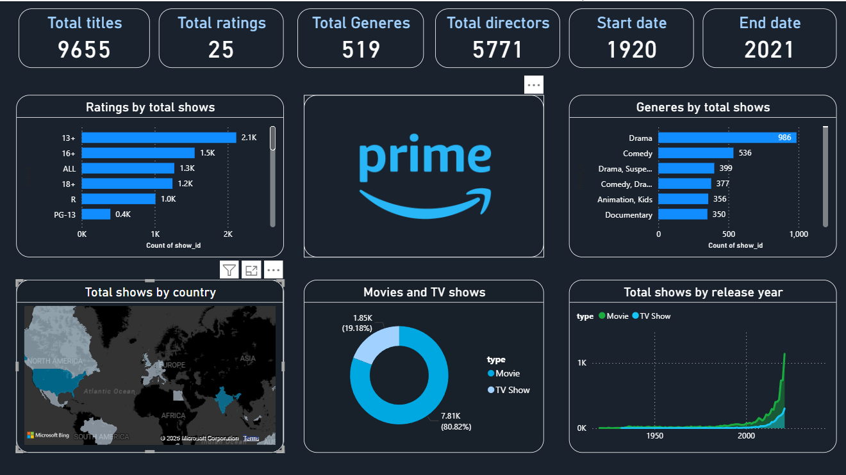

**Conclusion**

The Amazon Prime Dashboard Project provides valuable visibility into user behavior, content performance, and subscription trends. It equips decision-makers with the tools to optimize content strategies, improve user experience, and enhance overall service efficiency.